34.115:

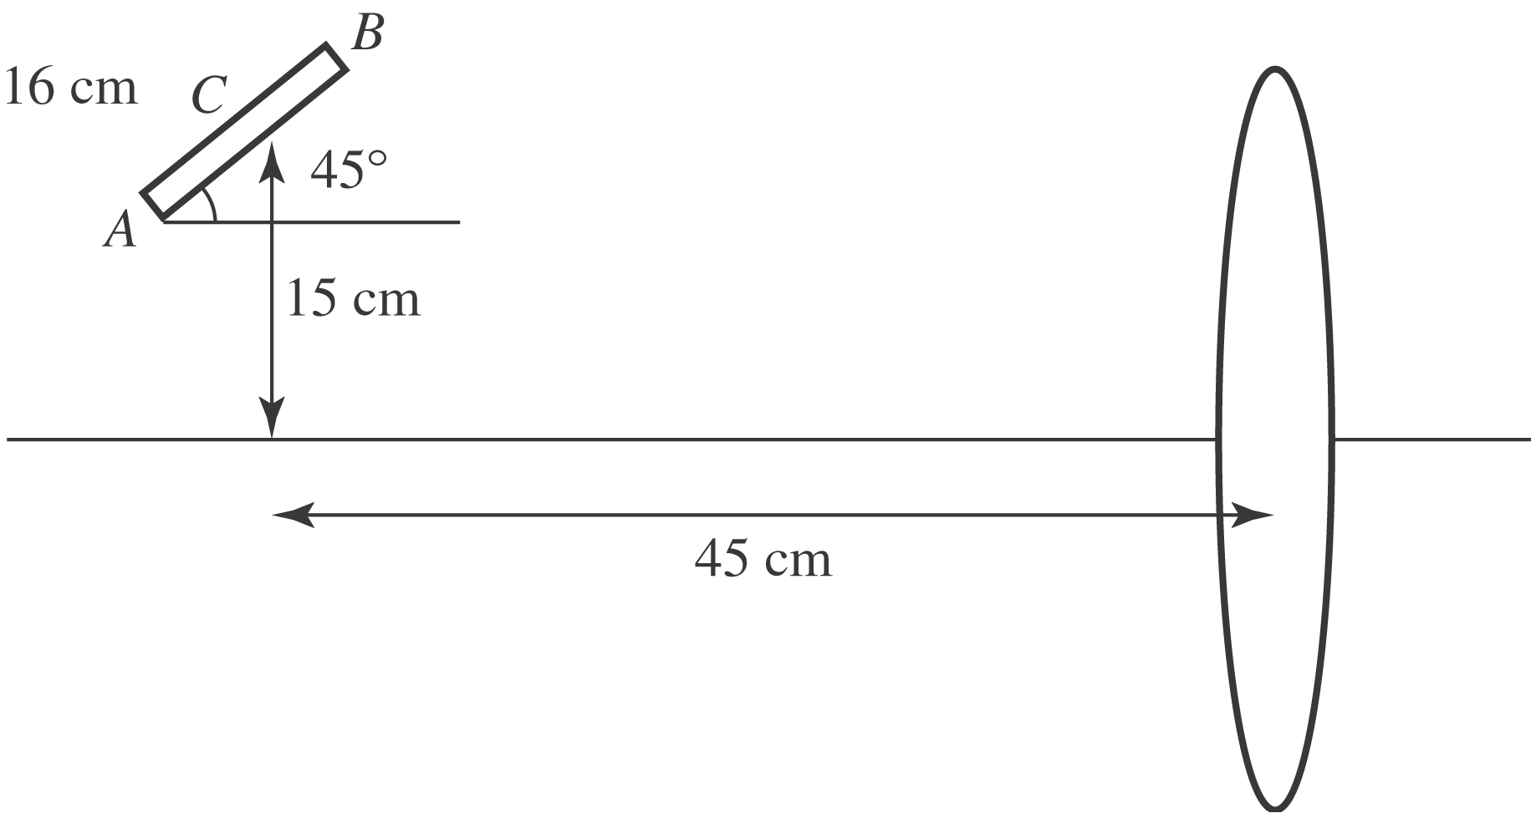
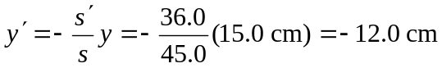, so the image of point C isto the right of the lens, and below the axis.
For point A:
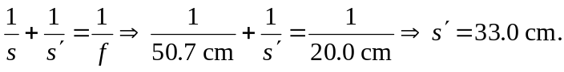
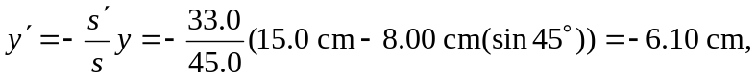so the image of point A is 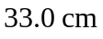to the right of the lens, and 6.10 cm below the axis. For point B:
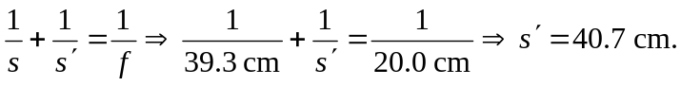
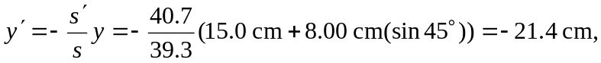so the image of point B is 40.7 cm to the right of the lens, and 21.4 cm below the axis.
b) The length of the pencil is the distance from point A to B:
